

Breast Cancer Risk Modeling:

An Application of Bayes Nets

John S. Uebersax

Methodology Division Research Report
Date: 2 August 2004

Breast Cancer Risk Modeling:
An Application of Bayes Nets
John S. Uebersax

Executive summary
In coming years, medical research and practice will rely increasingly on advanced diagnostic tests and individual genetics data. This will pose many challenges and opportunities for the development of novel, computation-intensive quantitative methods for evidence integration and decision-making. Bayesian statistical methods are likely to be central to this endeavor. In particular, a statistical method called Bayes networks shows considerable promise. This report describes the use of Bayes networks to make fully personalized estimates of breast cancer risk based on (1) breast cancer diagnosis history and (2) breast cancer gene (BRAC1) test results of any blood relative for whom either variable is known.. Principle virtues of Bayes networks in this application include the following:

- The network supplies risk estimates in the form of posterior probabilities – i.e., the probability that a given woman will develop breast cancer, given the cancer history and/or BRAC1 status of blood relatives.

- The probability estimate is automatically updated whenever new data become available.

- The network is built with off-the-shelf software, permitting extremely rapid development time.

- New network nodes can be easily added to accommodate additional variables.

Bayes networks show considerable promise for the diagnostic- and genomic-intensive medicine of the future. Indeed, it is difficult to imagine a method better suited. Progress in the field has been hampered by insufficient numbers of statisticians and computer scientists trained in these methods.

AI Research Report
Breast Cancer Risk Modeling:
An Application of Bayes Nets

John Uebersax, PhD

RavenPack International SL
July 14, 2004 (rev. 2 Aug 2004)

While conducting our research on the use of Bayes Nets in prostate cancer prediction, it became clear that these same methods have implications that extend far beyond this particular area. Indeed, there is good reason to believe that Bayes Nets represent a fundamental paradigm shift and step forward in the statistical analysis and artificial intelligence. An important example of this is the integration of genetic and clinical medical evidence. As this topic is one of the most significant fronts of advances in health care, it is instructive to show how the same methods used for our prostate Bayes net can be applied to solve a practical problem in the area of genetics.

Specifically, we consider the case of helping decide if a patient should receive genetic testing for the breast cancer gene, BRCA1.

Background

Currently, genetic testing methods are available to determine if a woman has a cancer-promoting alteration of the BRCA1 gene. Women with this alteration are substantially more likely to develop breast cancer (and ovarian cancer). Testing is done by drawing a sample of blood, and sending the sample to a central lab. The testing is expensive, can only be performed at a limited number of sites, and may involve significant time delay. Further, the population prevalence of BRCA1 alteration (except for people of Ashkenazi Jewish ancestry) is relatively low. These factors make the decision to receive BRCA1 testing a complex one.

Women with relatives who have had breast cancer (especially when the breast cancer occurs before the age of 40) are more likely to have BRCA1 alteration. Therefore it is increasingly common in genetic counseling centers to consider a woman's family history: that is, for all her female first- and second-degree relatives, what are their ages, which

Figure 1. A Mendelian Diagram

have had breast cancer, and, for those who have had breast cancer, what was the age of onset. From this information, one can apply statistical formulas to calculate the probability of the client having BRCA1 gene alteration; if this probability is sufficiently high (e.g., 5%), then the woman is referred to genetic testing.

Due to the potential complexity of a family history, these calculations are too difficult to perform manually. Rather, complex programs have been written to make them (best known is BRCAPRO, Berry et al., 2002). What we show here is that using simple Bayes Nets one can perform these calculations quite easily.

Figure 1 shows a simple Mendelian diagram for a hypothetical family. Circles represent females and squares represent males. The individuals shown include the client and her sister, parents, maternal and paternal grandparents, and maternal aunt.

Bayes Net Approach

The same information can be expressed in a Bayes Net as shown in Figure 2.

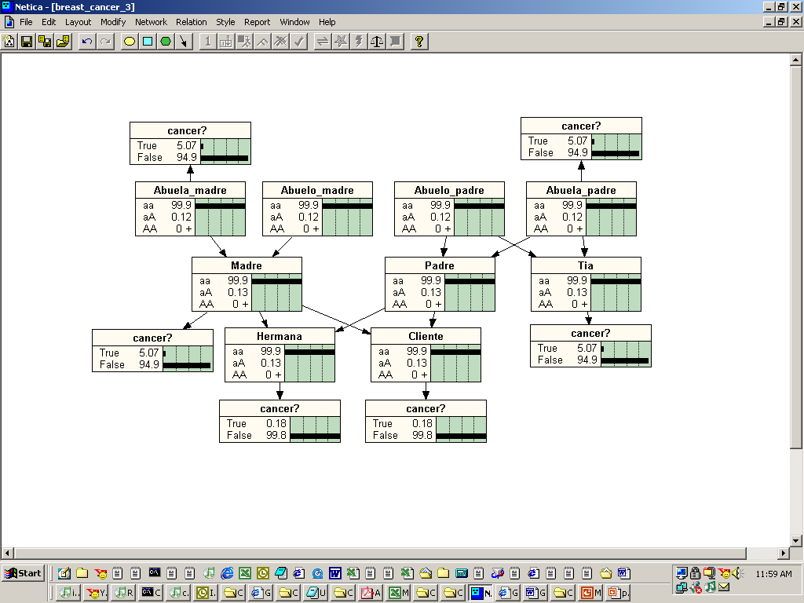
Note: Abuela = grandmother; madre = mother; padre = father; hermana = sister, tia = aunt.

Figure 2. Bayes Network for BRCA1 Alteration and Breast Cancer in Family

The Bayes network contains two types of nodes: for each person, a genotype node, and for each female, a cancer node. A genotype can have three states: (1) two copies of an intact BRCA1 gene (aa); (2) one intact and one altered BRCA1 gene (aA); and (3) two copies of an altered BRCA1 gene (AA). These three types are known as homozygous-unaffected, heterozygous, and homozygous-affected individuals, respectively.

Breast cancer status has two conditions, True and False. True means the individual has or had a diagnosis of breast cancer.

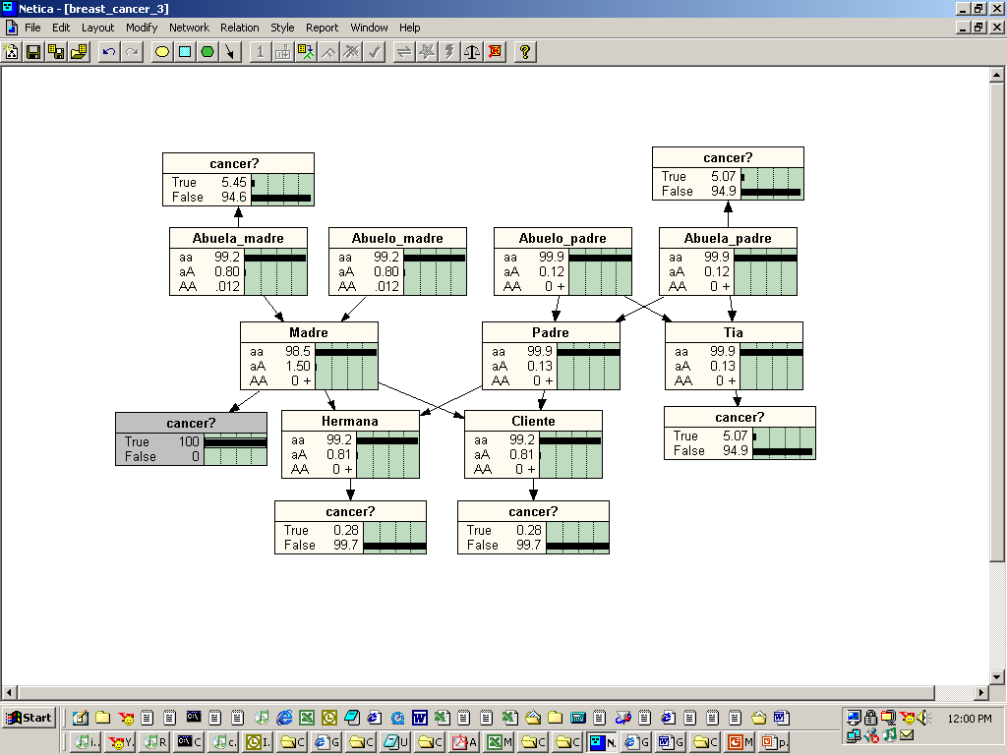
Note: Abuela = grandmother; madre = mother; padre = father; hermana = sister, tia = aunt.

Figure 3. Increased but Small Risk of BRCA1 Alteration Given Breast Cancer in Mother

Following current literature, we assume the BRCA1 gene has a simple autosomal dominant Mendelian inheritance pattern. Autosomal means it is not sex-linked: the gene can be transmitted by either a male or female parent. Simple dominance implies that Aa and AA females have the same risk of breast cancer.

Based on current literature, we assume that the prevalence of the altered BRCA1 gene is 1 per 800 women. Because subject age is an important factor, related to the probability of breast cancer among women both with or without BRCA1 gene alteration, we made this exercise simpler by assuming (1) the client and her sister are approximately 35 years old; (2) the client's mother, aunt, and grandmother were evaluated for breast cancer one time only each at age 60. These assumptions are by no means necessary to the Bayes Net approach; we only make them to simplify the task. In an actual application, one would consider age-specific cancer prevalence rates (for individuals with or without BRCA1 alteration), obtained either from tabled epidemiological data or modeled by parametric (e.g., survival analysis) formulas.

In Figure 2 we assume we have no information about the genetic or diagnostic status of any family member. In this case, the client has a only a 0.13% chance of carrying an altered BRCA1 gene.

In Figure 3, the client's mother is assumed to be breast-cancer positive. Based on the calculations of the Bayes Network, this increases the client's probability of having a defective BRCA1 gene to .81%--still so low that one might not recommend genetic testing.

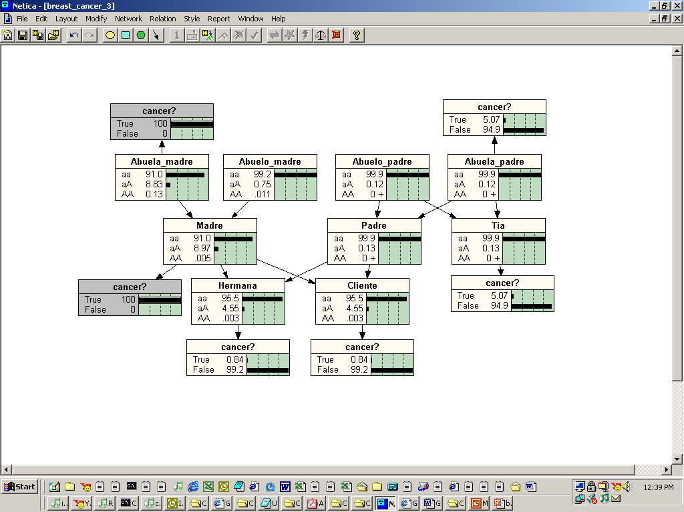
Note: Abuela = grandmother; madre = mother; padre = father; hermana = sister, tia = aunt.

Figure 4. Significant Risk of BRCA1 Alteration Given Breast Cancer in Mother and Maternal Grandmother

Figure 4 supposes that both the client's mother and grandmother have had breast cancer. In this case, the client has a probability of 4.55 + .003 = 4.553% of carrying at least one copy of the BRCA1 mutation. With this level of increased risk, the client may wish to receive genetic testing to confirm presence/absence of the BRCA1 defect.

Finally, we use the model to consider the influence of knowing a relative's genetic status. Specifically, Figure 5 assumes that the maternal grandmother was known to carry the BRCA1 gene. In this case we see the client's risk of carrying the gene is slightly over 25%.

Even this simple example, then, produces a useful result—one obvious in retrospect, but not necessarily obvious otherwise: from a public health financing standpoint, it is more cost-effective to genetically test older generations in a family tree than younger generations. For example, if both parents are found free of the BCRA1 mutation, then there is no need to test any of their children, or if any grandparent is found to carry the alteration, then all of their female children and grandchildren should be tested.

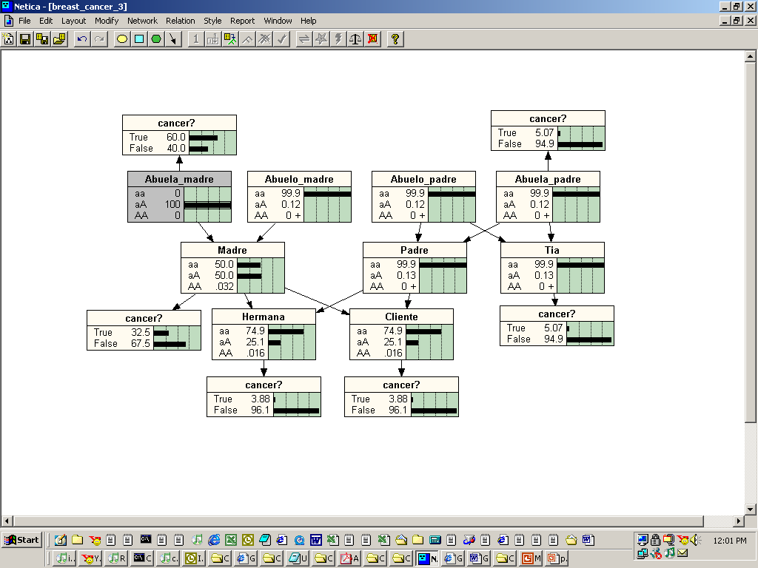
Note: Abuela = grandmother; madre = mother; padre = father; hermana = sister, tia = aunt.

Figure 4. Large Risk of BRCA1 Alteration Given Breast Cancer in Mother and Sister

Conclusions

This exercise shows how Bayes Nets are inherently suited to medical problems that involve genetic factors. They can be used to predict genotype, or to make diagnoses using complete or incomplete genetic information from a family pedigree. In fact, the BRCAPRO model (Berry, 2002), the most sophisticated system available for making decisions about BRCA1 testing, is, from a mathematical standpoint, a type of Bayes Network, although the developers do not identify it as such.

The current model could be easily extended in several ways. One would be to include information on nongenetic risk factors for each relative. For example, if a female relative has breast cancer, but also had many nongenetic breast cancer risk factors, then this would lower the estimated probability of the client having a BRCA1 alteration. It is known that early onset of breast cancer and bilateral breast cancer are stronger evidence of BRCA1 alteration than late-onset and unilateral breast cancer. These factors could be easily added to the model shown here.

The basic conclusion is that Bayes Nets are a convenient and appropriate method for genetic counseling and use of genetic information in patient diagnosis. Further, one might suggest that Bayes Nets are the most appropriate framework for approaching these problems. The simplicity of the Bayes Net formulation insures that models can be updated easily as new scientific information becomes available, or tailored to the specific data (e.g., prevalence rates, age-risk rates) of a regional population. Further, one can place utility and decision nodes in a Bayes Net (the result is called an Influence Diagram). With these nodes, the net not only can be used to predict probabilities of genotype, disease or outcome, but also to recommend specific cost-effective choices.

The recognition that Bayes Nets could be used in this way occurred to us unexpectedly. We were considering genetic screening as a separate issue, when it suddenly became apparent that this could be easily done with Bayes Nets. We believe this is only one of what are probably a very large number of disparate health-related decision problems which can be simplified and, in a sense, unified, by approaching them as Bayes Nets.
This reaffirms our decision to have Bayes Nets as one of the main areas in which AlphaMedic Systems can develop unique expertise and provide valuable services to health care organizations.

Notes

Bayes Nets shown here were produced using the computer program Netica™, by the Norsys Software Corporation (http://www.norsys.com/netica.html).

References

Berry DA, Iversen ES Jr, Gudbjartsson DF, Hiller EH, Garber JE, Peshkin BN, Lerman C, Watson P, Lynch HT, Hilsenbeck SG, Rubinstein WS, Hughes KS, Parmigiani G.
BRCAPRO validation, sensitivity of genetic testing of BRCA1/BRCA2, and prevalence of other breast cancer susceptibility genes. J Clin Oncol. 2002;20(11):2701-12.

Harris NL. Probabilistic belief networks for genetic counseling. Comput Methods Programs Biomed. 1990 May;32(1):37-44.

Lauritzen SL, Sheehan NA. Graphical models for genetic analyses. Statistical Science 2003; 18 (4), 489–514.

Le T. BRCA1 and BRCA2 Mutations. PowerPoint presentation, 2003. Myriad Genetics, www.myriad.com.

Szolovits P, Pauker SP. Pedigree analysis for genetic counseling. In Lun KC et al. (eds.), MEDINFO 92: Proceedings of the Seventh Conference on Medical Informatics, pp. 679-683. Holland: Elsevier, 1992.

REVISION HISTORY
Version | Date changed | Pages changed | Description of change | Changes made by
v. 1 | 2004-07-14 | all | First version
v. 2 | 2004-08-02 | all | Final distribution version
 | 2009-08-12 |  | posted online; added note about Netica

Mendelian genetics would imply a 25% chance of inheriting the defect from the maternal grandmother. However, there is also a small probability of inheriting it from another relative.

